PROBLEM:
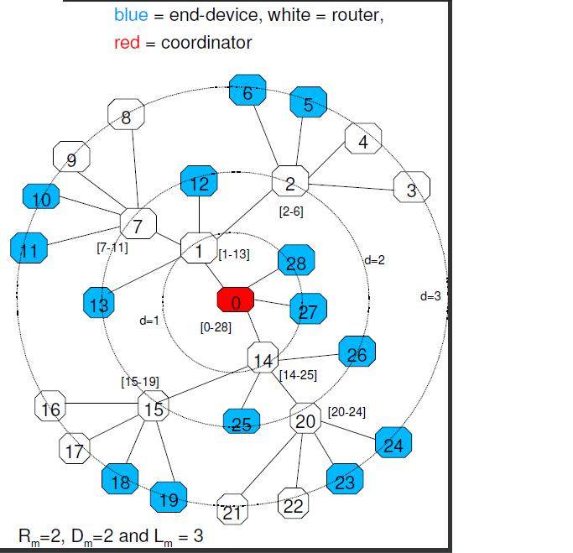
Explain how the address, i.e., the number within the node, is assigned.

Answer:

A(2)=1+D_{m}+R_{m}=1+2+2=5 (d=2=L_{m}-1)
A(1)=1+D_{m}+R_{m}*A(2)=1+2+2*5=13 (0≤d<L_{m}–1)
A(0)= 1+D_{m}+R_{m}*A(1)=1+2+2*13=29 (0≤d<L_{m}–1)
Address range of coordinator R₀: [x, x+A(0)]=[0, 29]
R₀ will assign address range: [x+(i-1)*A(d+1)+1, x+i*A(d+1)] to its ith router child where (1≤i ≤Rm)
- 1st router child: [0+(1-1)*A(1)+1, 0+1*A(1)]=[1,13]
- 2nd router child: [0+(2-1)*A(1)+1, 0+2*A(1)]=[14,26]
R₀ will assign address: x + R_{m}*A(d+1)+j to its j^{th} end device child (1≤j ≤D_{m})
- 1st end-device child: 0+2*A(1)+1=27
- 2nd end-device child: 0+2*A(1)+2=28
And repeat this address allocation for deeper level!
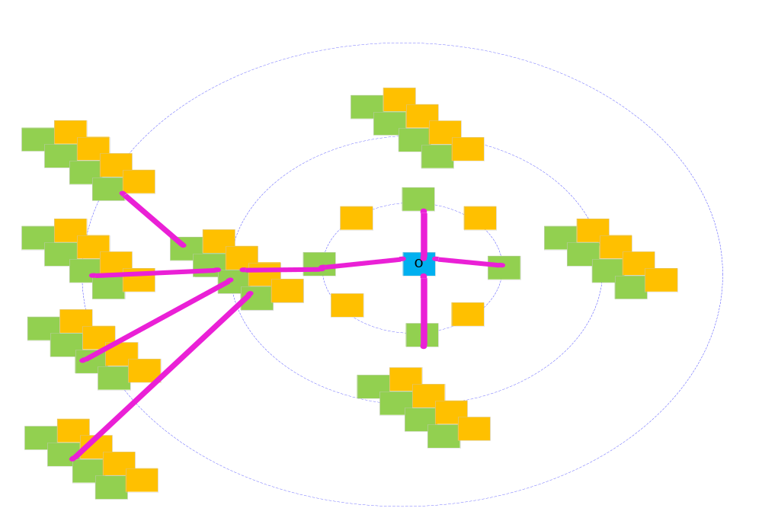Rm=4, Dm=4, Lm=3
Nốt BLUE: Coordinator/FFD, Nốt GREEN: Router/FFD, Nốt ORANGE: End Device/RFD

